.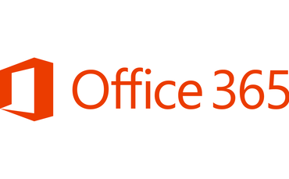
WITT students can access the Microsoft Office Suite online or to download – FREE!
Users can store the files they create with Office 365 ProPlus on their local computers or elsewhere on your network, such as a SharePoint site.
The Office programs that come with Office 365 ProPlus are the same programs that come with Office Professional Plus 2019.

- Log into your WITT email account from home at www.outlook.com/taranaki.ac.nz

To download the Office 365 software for your home computer
- Select the Settings button as circled below
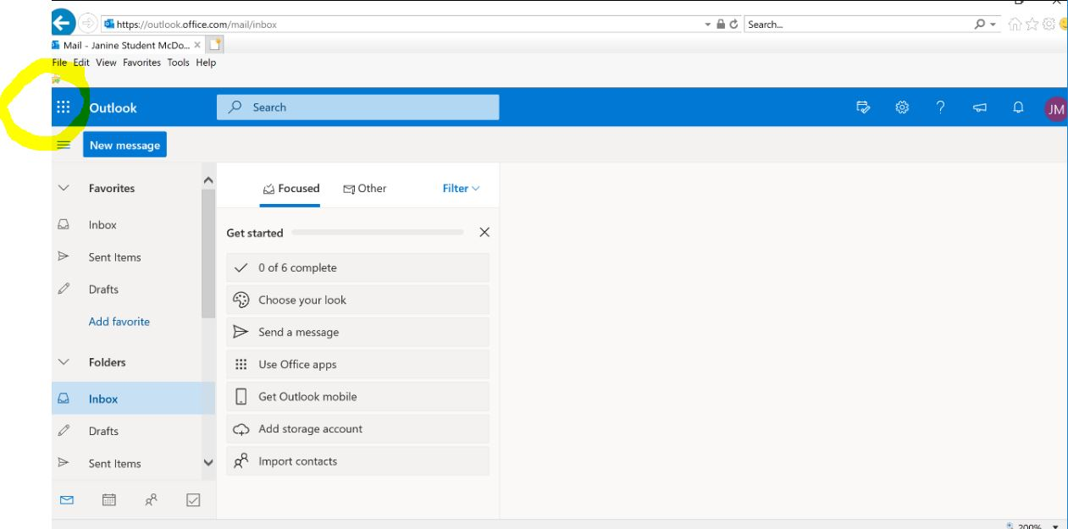

- Select Office 365
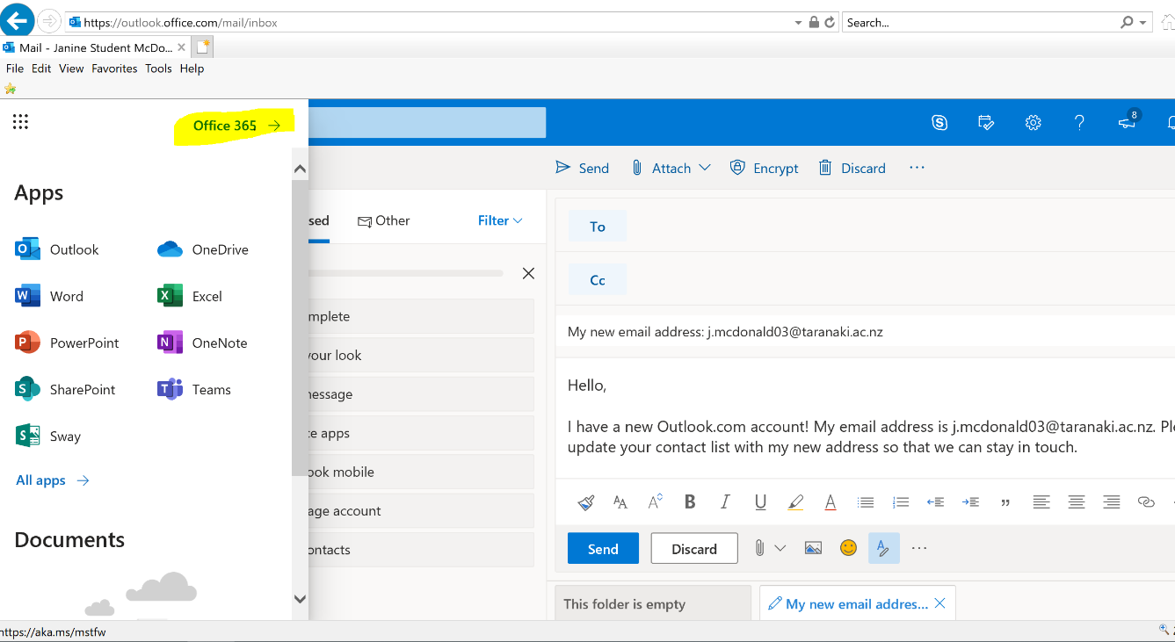

- Click the Install Office button
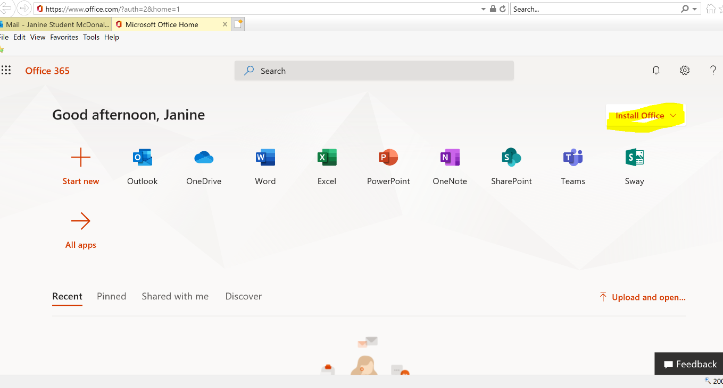

- Select Office 365 apps
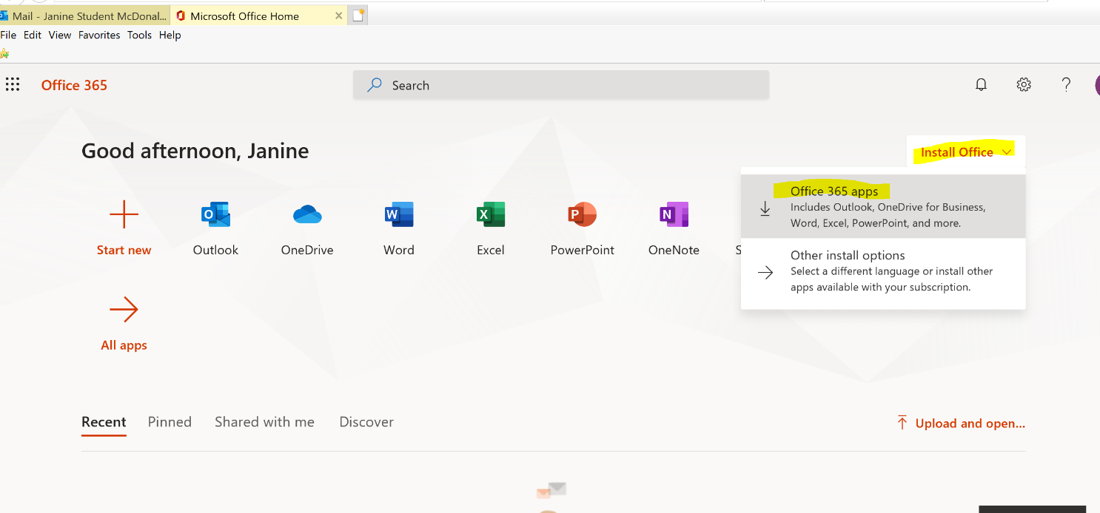

- The download will then start
